Experiment: -11 Installing and setup Ansible Server and Nodes

1. Create 2 AWS linux EC2 instances.

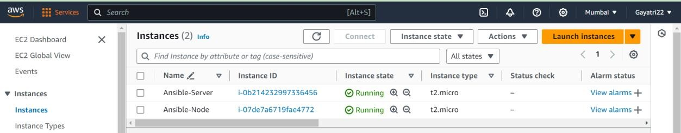

1. Install ansible in Server machine.



1. Add private ip of Node machine in list of known hosts in **/etc/ansible/hosts** file.

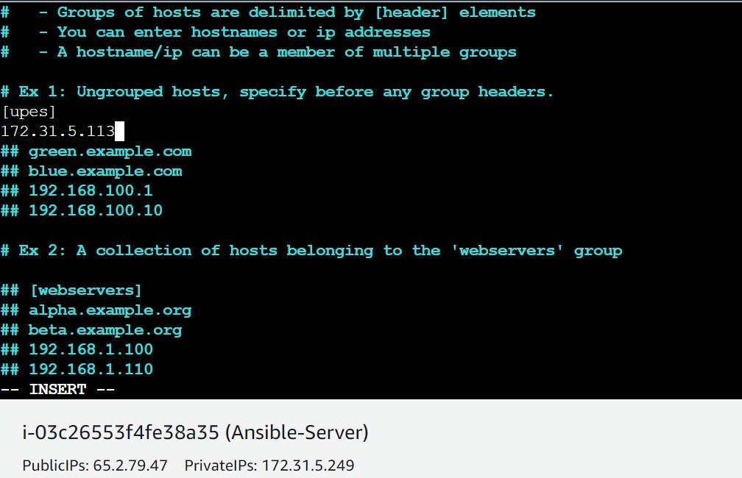

1. adduser ansible in both server and node machine.

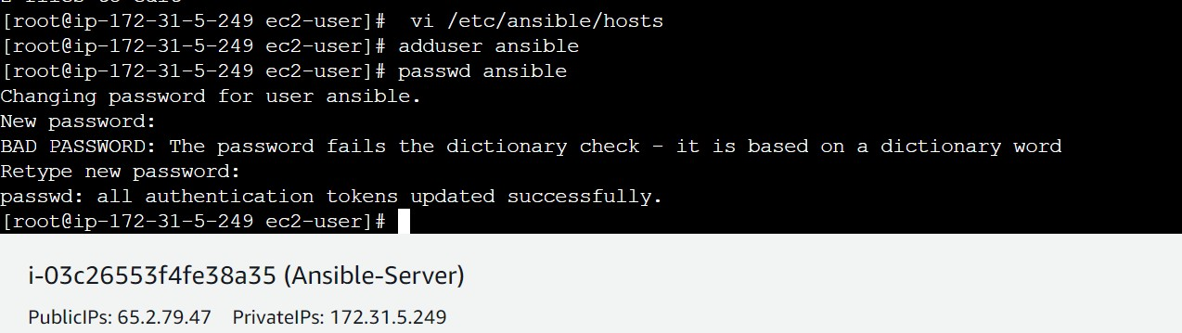

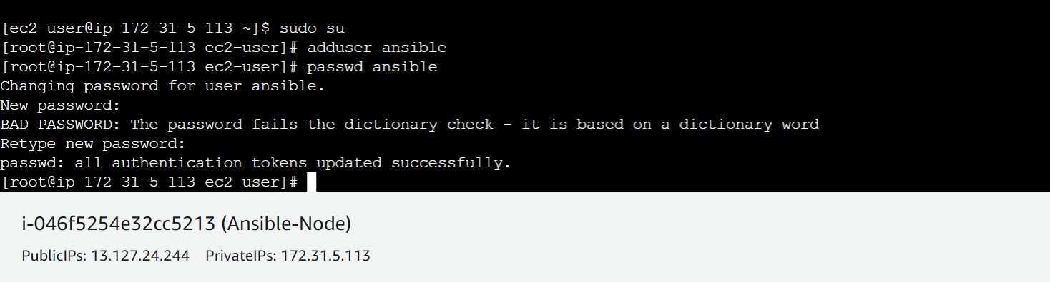

1. we have to generate a key pair and copy that into node machine.

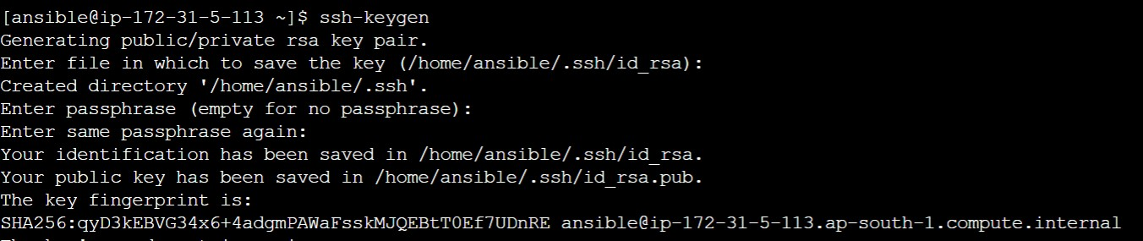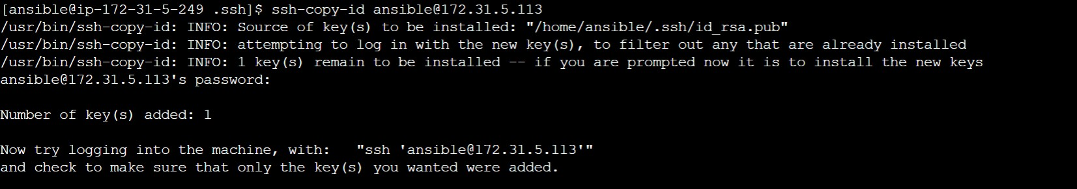

1. key has been successfully added, now we can go into node machine through server only by ssh-ing into its private IP

